**Disable UC Engine Update**

In order to disable updates on UC Engine perform following steps

1. Go to <https://github.com/hit-play/UCEngine-Disable-Update.git>
2. From there download DisableUCEngineUpdate.ps1 file
3. The following steps need to be performed on UC Engine
4. Copy DisableUCEngineUpdate.ps1 file to UC Engine.
5. Open “Task Scheduler”.
6. Click on ”Task Scheduler Library” Highlighted as 1
7. Click on “Create Task” Highlighted as 2

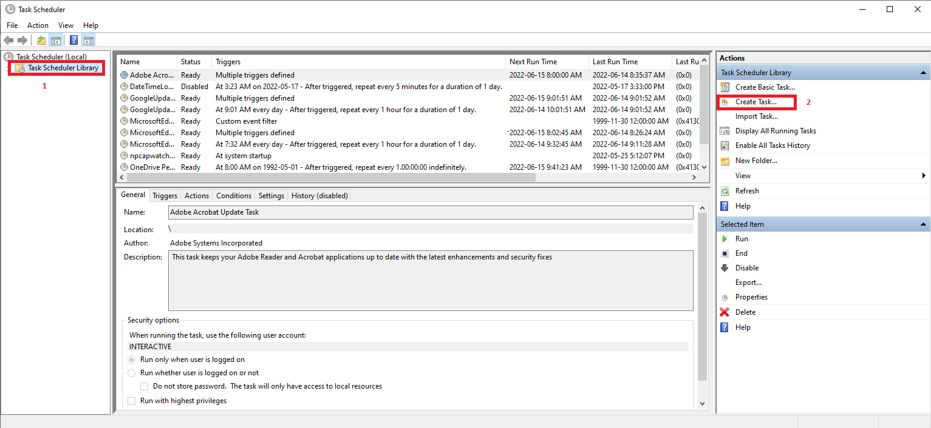

1. It will open the Create task window. Match all highlighted fields as shown in following image

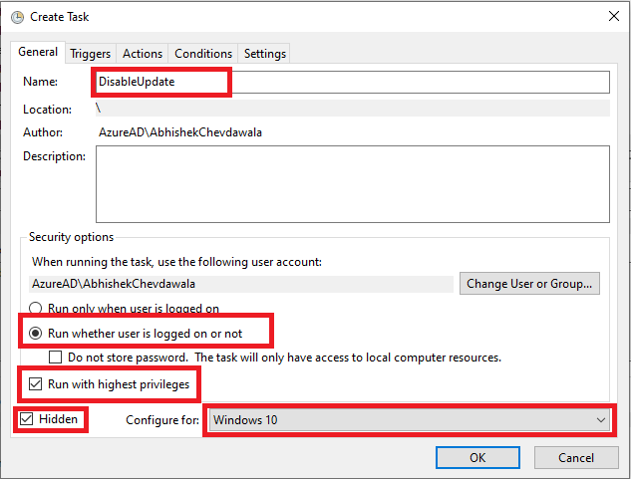

1. Click on “Trigger” tab on this window
2. Click on “New” button. It will open “New Trigger” window.

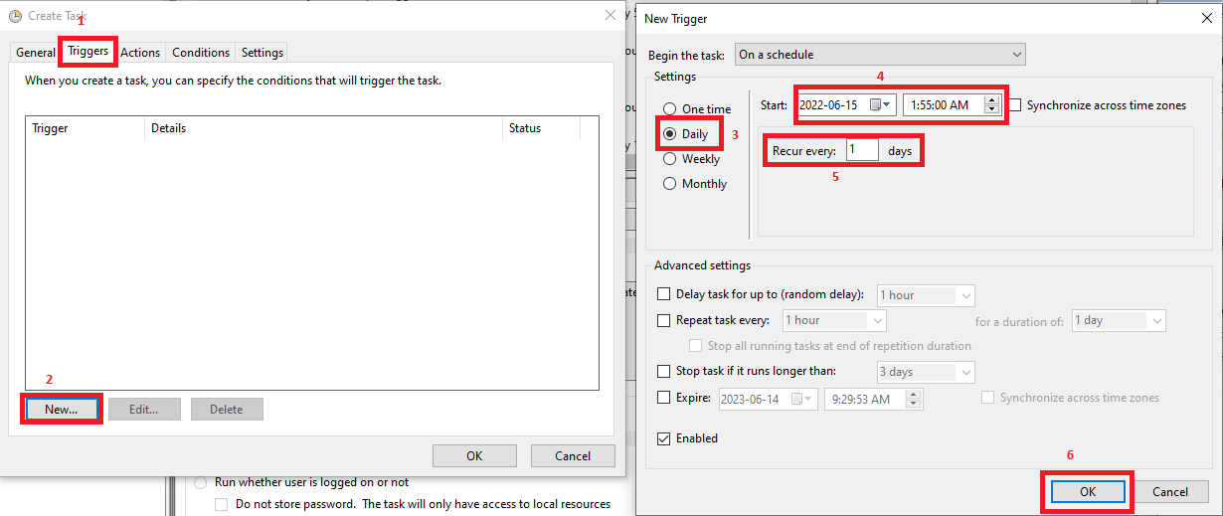

1. Match filed all fields on this window. Make sure field 4 has the next day date. Then click on Ok. This will bring you back on “Create Task” window.
2. Click on “Action” Tab. It will open “New Action” window.

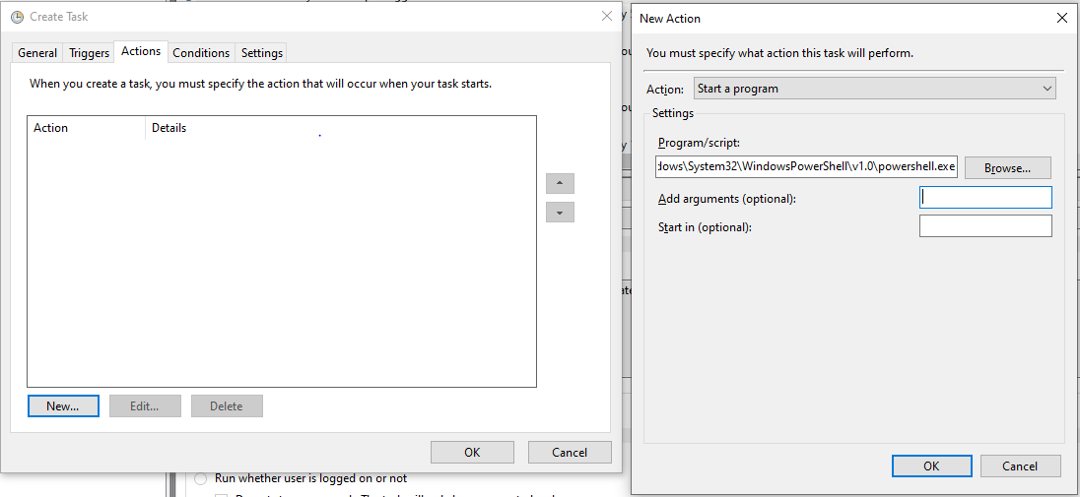

1. In “Program/Script” type “C:\Windows\System32\WindowsPowerShell\v1.0\powershell.exe”
2. In “Add Arguments” type “-NoProfile -NoLogo -NonInteractive -ExecutionPolicy Bypass –File DisableUCEngineUpdate.ps1”
3. In “Start In” type folder location where you have the DisableUCEngineUpdate.ps1 file
   1. For example, “D:\Development\Powershell Automation\”. Here do not use double quotes
4. Click on “OK”. This will bring you back on “Create Task” window
5. Click on “OK”. This will bring you back on “Task Scheduler” window.

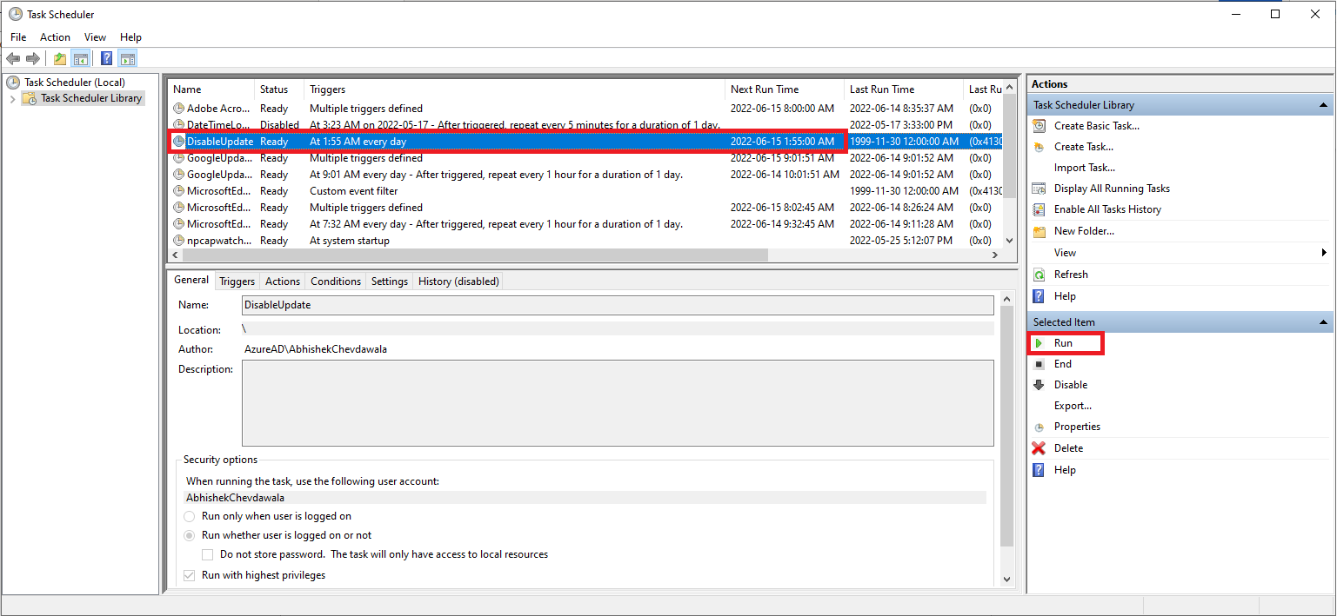

1. You should be able to see your new task with name “Disable Update”. Select that and click on “Run”.
2. Now you can expand “Task Scheduler Library” and go to “Microsoft/Skype”. You should be able to see “Nightly Reboot” task should be “Disabled”.